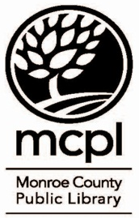
VITAL (Volunteers In Tutoring Adult Learners)
Tutoring Log
Monroe County Public Library
303 East Kirkwood Avenue
Bloomington, IN 47408-3534
(812) 349-3173
vital@mcpl. info

Learner’s Name: |  |  | Tutor’s Name:
Learner’s Long -Term Goals:  Learner’s Short -Term Objectives: |  |  |  | Date: From  To-
Session Number | Session Date | Learning Activities/Materials Used |  |  | Prep/ Tutoring Time

Session Number | Session Date | Learning Activities/Materials Used | Prep/ Tutoring Time

